Elior Bilow
Recitation 4
MEGN471 – Colorado School of Mines
2022-02-16

You’re tasked with making a heatsink for an electric motor with a design similar to that shown in figure 1. The heatsink is to be made from extruded aluminum. The outer dimensions of the motor you’re designing for is 11cm wide and 15cm long. The heatsink around the motor should have a base with a thickness of 6mm. Each fin has a rectangular profile and a thickness of 3mm and there are 43 total fins. The motor consumes around 5kW of power and is 90% efficient (you can assume inefficiencies are let off as heat into the heatsink).
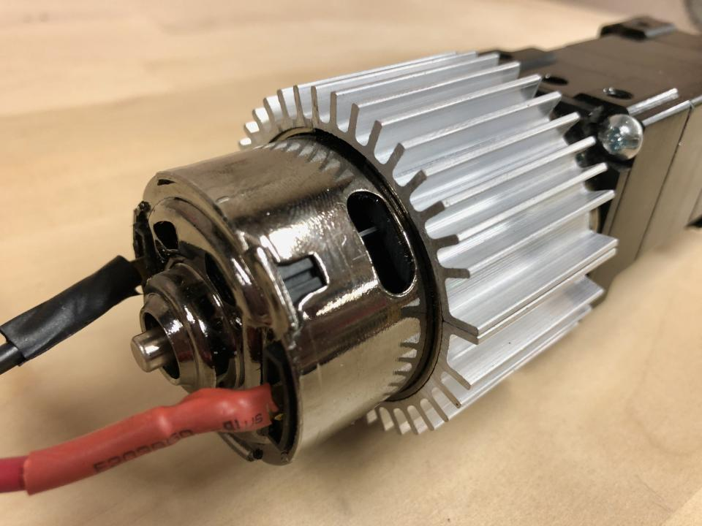
Figure 1: Structure of the cooler being made.

Questions:
- The motor has a maximum surface temperature of 80 degC. Assuming the surrounding air temperature is 20 degC, what’s the maximum thermal resistance allowed between the exterior of the motor and the surrounding air?
- Given the heatsink base is 6mm thick, what is the thermal resistance of the base of the heatsink (due to conduction)? Use the properties of pure aluminum.
- What is the thermal resistance at the exterior of the base of the heatsink (due to convection)? Assume the convection coefficient is 25 W/(m²*K).
- With the maximum allowable thermal resistance, the conductive thermal resistance of the base of the heatsink, and the convective resistance of the base of the heatsink, what’s the maximum allowable thermal resistance of the entire fin array?
- How hot is the base of the fin array? What is theta_b?
- How much heat will be going through each fin if they’re as short as possible?
- What’s the minimum height of each fin?

